EEZ PSU H24005 wire harness
- Ethernet cable
- Cooling fan cable
- AUX temperature sensor cable
- AC switch patch cables
- Cable set #1
- Cable set #2
- Pre-assembled cables
- BOM

Ethernet cable
Total length | 250 (± 5) mm
Type | 4 pairs Ethernet, stranded wire
TME | HELUKAT100-FTP-FP or e.g. cut CA00600.00C01 to size
Farnell | 1602385 or e.g. cut 1734894 to size
Connectors
Side A | X8 | Side B | X18
Housing type | Receptacle, 0.1” | Housing type | See side A
TME | NSR-08 | TME | See side A
Farnell | 865667 | Farnell | See side A
Pin: | Female | Pin | See side A
Pin quantity | 8 | Pin quantity | 7
TME | NDR-T | TME | See side A
Farnell | 1022219 | Farnell | See side A

Wiring
Name | Position | Color / description | Position | Color / description
LED link | 1 | Brown-white | 1 | Brown-white
LED act | 2 | Brown | 2 | Brown
Shield | 3 | Blue-white | 3 | NOT CONNECTED
RX+ | 4 | Orange-white | 4 | Orange-white
RX- | 5 | Orange | 5 | Orange
TX+ | 6 | Green-white | 6 | Green-white
TX- | 7 | Green | 7 | Green
+3.3V | 8 | Blue | 8 | Blue

Picture
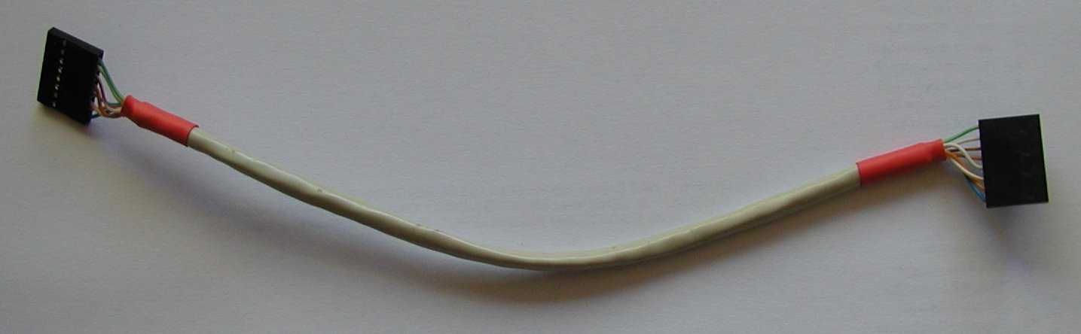

Cooling fan cable
Total length | 100 (± 5) mm
Type | 3 wire, already mounted on the cooling fan
Fan: | TME: MB60251V1-G99
Connectors
Side A | X6 | Side B | N/A
Housing type | Receptacle, 0.1” | Housing type | N/A
TME | MX-6471-031 | TME | N/A
Farnell | 143127 | Farnell | N/A
Pin | Female | Pin | N/A
Pin quantity | 3 | Pin quantity | 0
TME | MX-0850-0114 | TME | N/A
Farnell | 2063734 | Farnell | N/A
Additional info
Fan is already equipped with cable that has to be cut to size and terminated with connector

Wiring
Name | Position | Color / description
12 Vdc | 1 | Red
GND | 2 | Black
Sense | 3 | Yellow

Picture
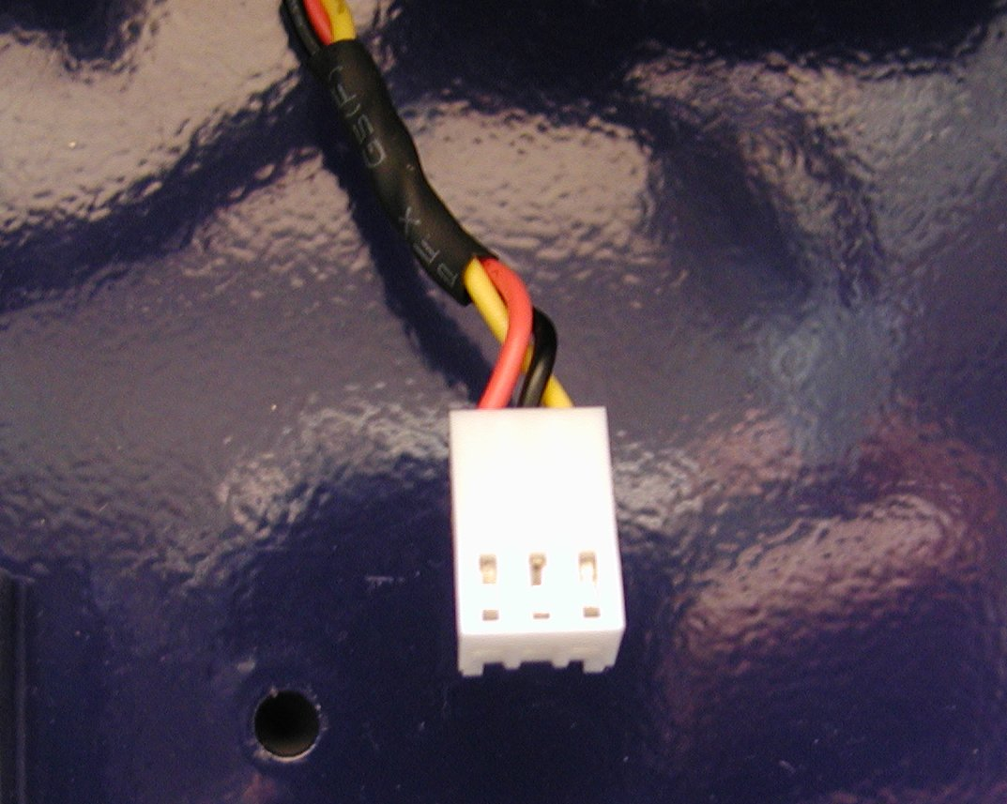

AUX temperature sensor cable
Total length | 145 (± 5) mm
Type | Max. 0.35 mm² singe wire, stranded
TME | E.g. brown: LGY0.35/25-BR (or any other color)
Farnell | E.g. brown: 2425402 (0.22 mm²)
NTC | TME: NTCLE100E3103JB0, Farnell: 1187031
Wire | TME: LGY0.35/25-BR, Farnell:
Connectors
Side A | X17 | Side B | N/A
Housing type | Receptacle 0.1” | Housing type | N/A
TME | MX-6471-021 | TME | N/A
Farnell | 143126 | Farnell | N/A
Pin | Female | Pin | N/A
Pin quantity | 2 | Pin quantity | 0
TME | MX-0850-0114 | TME | N/A
Farnell | 2063734 | Farnell | N/A
Additional info
The temperature sensor is already equipped with cable that has to be terminated with connector

Wiring
Name | Position | Color / description
MCU_VCC | 1 | Any color
NTC | 2 | Any color

Picture
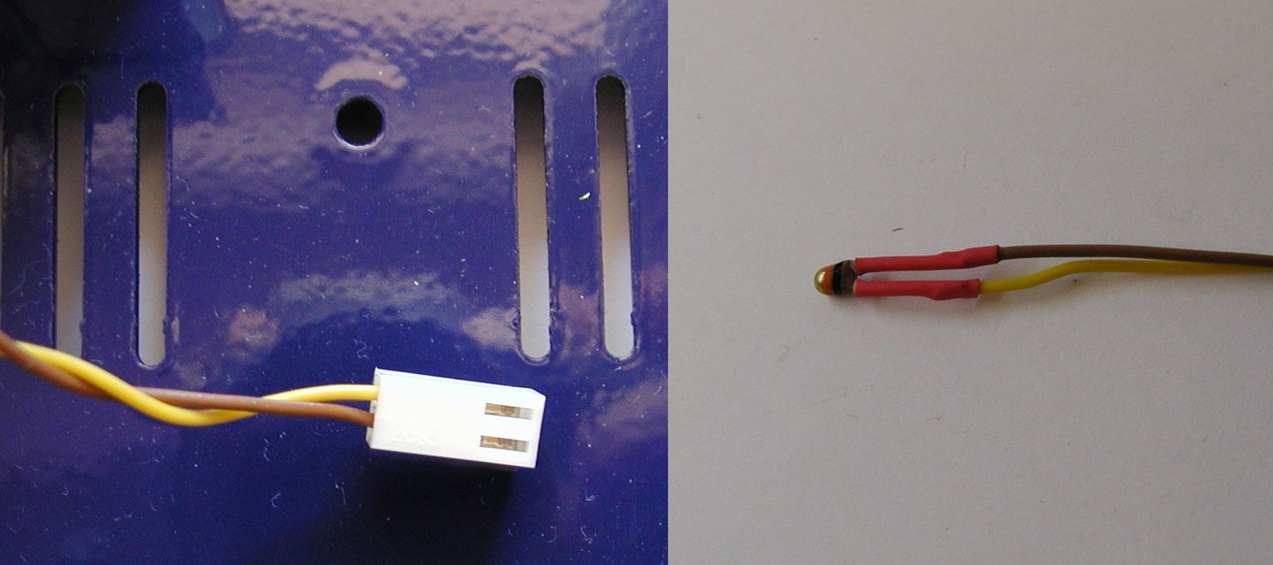

AC switch patch cables
Total length | 45 (± 5) mm
Type | 0.75 mm² singe wire, stranded, min. 250 VAC
TME | Brown: LGY0.75/25-BR, Blue: LGY0.75/25-BL
Farnell | Brown: 2528103, Blue: 2528092
Connectors
Side A | AC output | Side B | AC Switch input
Pin | Female quick disconnect | Pin | See side A
Pin quantity | 2 | Pin quantity | See side A
TME | BM01148 | TME | See side A
Farnell | 3625424 | Farnell | See side A
Additional info
Required for Schurter 4304.6090 IEC inlet (C14, 6765, 10A)

Wiring1
Name | Position | Color / description | Position | Color / description
Line | 1 | Brown | 1 | Brown

Wiring2
Name | Position | Color / description | Position | Color / description
Neutral | 1 | Blue | 1 | Blue

Picture
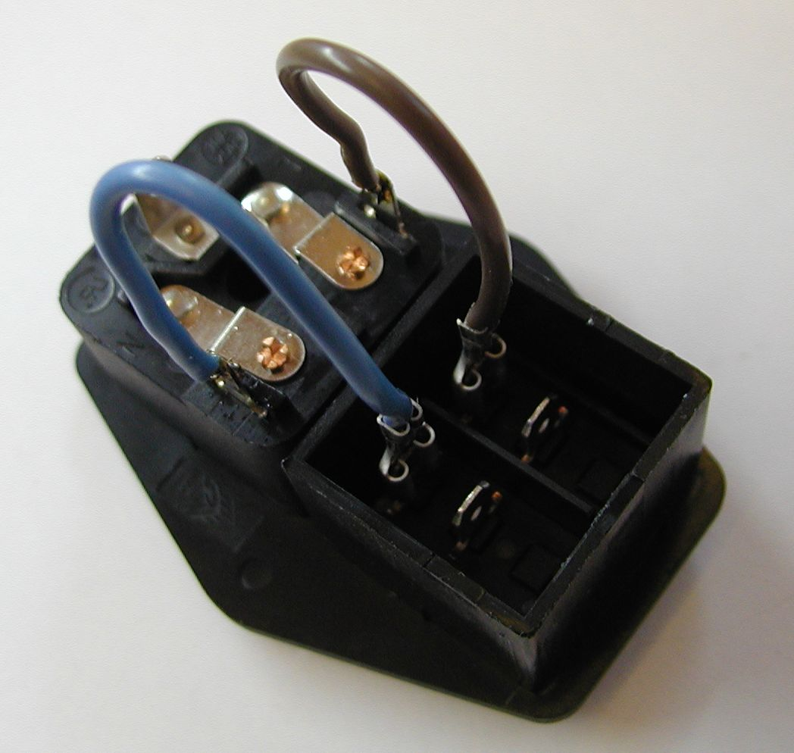

Cable set #1
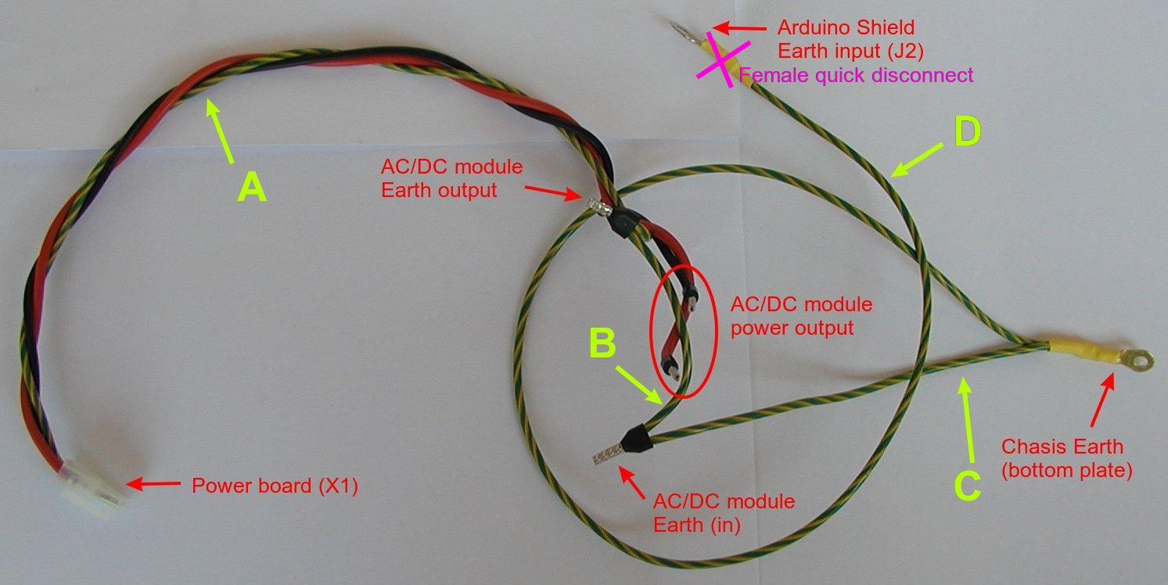

Section A: Power board X1 cable
Length | 400 (± 5) mm
Type | 0.75 mm² singe wire, stranded, min. 250 VAC
TME | Red: LGY0.75/25-RD, Black: LGY0.75/25-BK  Green-Yellow: LGY0.75/25-YL/GR
Farnell | Red: 2528175, Black: 2528082, Green-Yellow: 2528140
Connectors
Side A | Power board X1 (Ch2) | Side B | AC/DC module power output
Housing type | Male, Mini-Fit Jr. | Housing type | Ferrule, single wire
TME | MX-5557-03R2 | TME | H0.75/14D/GY
Farnell | 9963480 | Farnell | 841195
Pin | Female | Quantity | 2
Pin quantity | 3 | Housing type | Ferrule, twin entry
TME | MX-5556-T3L | TME | H0.75/15D2/GY
Farnell | 9732675 | Farnell | 1121751
 |  | Quantity | 1

Wiring
Name | Position | Color / description | Position | Color / description
Earth | 1 | Green-Yellow | N/A | Ferrule, twin entry
Vin- | 2 | Black | N/A | Ferrule
Vin+ | 3 | Red | N/A | Ferrule

Section B: AC/DC module Earth
Length | 70 (± 1) mm
Type | 0.75 mm² singe wire, stranded, min. 250 VAC
TME | LGY0.75/25-YL/GR
Farnell | 2528140
Connectors
Side A | AC/DC module Earth output | Side B | AC/DC module Earth (in)
Housing type | Use twin entry ferrule, See B side, Section A | Housing type | Ferrule, twin entry
 |  | TME | H0.75/15D2/GY
 |  | Farnell | 1121751
 |  | Quantity | 1

Section C: Chassis Earth
Length: | 170 (± 5) mm
Type: | 0.75 mm² singe wire, stranded, min. 250 VAC
TME | LGY0.75/25-YL/GR
Farnell | 2528140
Connectors
Side A | AC/DC module Earth (in) | Side B | Chassis Earth (bottom plate)
Housing type | Use twin entry ferrule, See B side, Section B | Housing type | Non-insulated, Ring terminal, 3 mm
 |  | TME | BM 91103
 |  | Farnell | 7356528
 |  | Quantity | 1

Section D: Arduino Shield Earth
Length: | 500 (± 5) mm
Type: | 0.75 mm² singe wire, stranded, min. 250 VAC
TME | LGY0.75/25-YL/GR
Farnell | 2528140
Connectors
Side A | Chassis Earth (bottom plate) | Side B | Arduino Shield Earth input (J2)
Housing type | Use ring terminal, See B side, Section C | Housing type | Female quick disconnect
 |  | TME | 1
 |  | Farnell | BM01148
 |  | Quantity | 3625424

Cable set #2
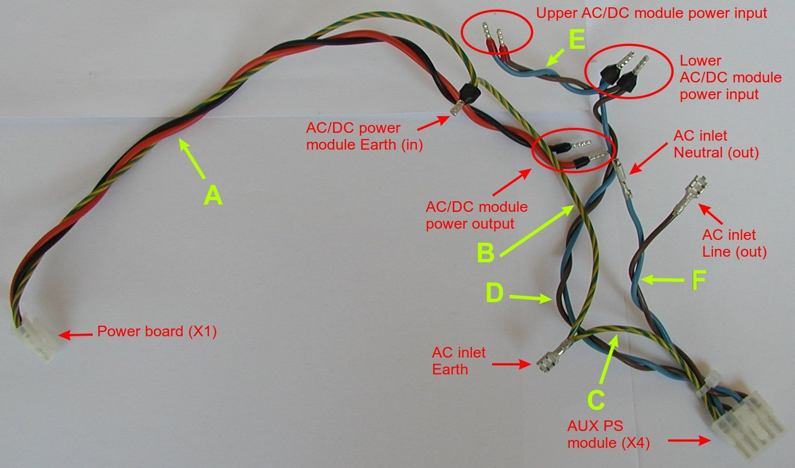

Section A: Power board X1 cable
Length | 330 (± 5) mm
Type | 0.75 mm² singe wire, stranded, min. 250 VAC
TME | Red: LGY0.75/25-RD, Black: LGY0.75/25-BK  Green-Yellow: LGY0.75/25-YL/GR
Farnell | Red: 2528175, Black: 2528082, Green-Yellow: 2528140
Connectors
Side A | Power board X1 (Ch1) | Side B | AC/DC module power output
Housing type | Male, Mini-Fit Jr. | Housing type | Ferrule, single wire
TME | MX-5557-03R2 | TME | H0.75/14D/GY
Farnell | 9963480 | Farnell | 841195
Pin | Female | Quantity | 2
Pin quantity | 3 | Housing type | Ferrule, twin entry
TME | MX-5556-T3L | TME | H0.75/15D2/GY
Farnell | 9732675 | Farnell | 1121751
 |  | Quantity | 1

Wiring:
Name | Position | Color / description | Position | Color / description
Earth | 1 | Green-Yellow | N/A | Ferrule, twin entry
Vin- | 2 | Black | N/A | Ferrule
Vin+ | 3 | Red | N/A | Ferrule

Section B: AC/DC module Earth
Length | 150 (± 5) mm
Type | 0.75 mm² singe wire, stranded, min. 250 VAC
TME | LGY0.75/25-YL/GR
Farnell | 2528140
Connectors
Side A | AC/DC power module Earth (in) | Side B | AC inlet Earth
Housing type | Use twin entry ferrule, See B side from Section A | Housing type | Female quick disconnect
 |  | Quantity | 1
 |  | TME | BM01148
 |  | Farnell | 3625424

Section C: AUX PS module Earth
Length | 150 (± 5) mm
Type | 0.75 mm² singe wire, stranded, min. 250 VAC
TME | LGY0.75/25-YL/GR
Farnell | 2528140
Connectors
Side A | AC inlet Earth | Side B | AUX PS module (X4)
Housing type | Use Female quick disconnect terminal, See B side, Section B | Housing type | Male, Mini-Fit Jr.
 |  | TME | MX-5557-05R2
 |  | Farnell | 9963502
 |  | Pin | Female
 |  | Pin quantity | 1
 |  | TME | MX-5556-T3L
 |  | Farnell | 9732675

Wiring:
Name | Position | Color / description | Position | Color / description
- | - | Female quick disconnect | 1 | Earth

Section D: Lower AC/DC module power input
Length | 200 (± 5) mm
Type | 0.75 mm² singe wire, stranded, min. 250 VAC
TME | Brown: LGY0.75/25-BR, Blue: LGY0.75/25-BL
Farnell | Brown: 2528103, Blue: 2528092
Connectors
Side A | AUX PS module (X4) | Side B | Lower AC/DC module power input
Housing type | See Side B, Section C | Housing type | Ferrule, twin entry
TME | - | TME | H0.75/15D2/GY
Farnell | - | Farnell | 1121751
Pin | Female | Quantity | 2
Pin quantity | 2
TME | MX-5556-T3L
Farnell | 9732675

Wiring:
Name | Position | Color / description | Position | Color / description
Neutral | 4 | Blue | N/A | Ferrule, twin entry
Line | 5 | Brown | N/A | Ferrule, twin entry

Section E: Upper AC/DC module power input
Length | 70 (± 1) mm
Type | 0.75 mm² singe wire, stranded, min. 250 VAC
TME | Brown: LGY0.75/25-BR, Blue: LGY0.75/25-BL
Farnell | Brown: 2528103, Blue: 2528092
Connectors
Side A | Lower AC/DC module power input | Side B | Upper AC/DC module power input
Housing type | Use twin entry ferrule, See B side, Section D | Housing type | Ferrule, single wire
 |  | TME | H0.75/14D/GY
 |  | Farnell | 1121751
 |  | Quantity | 2

Section F: AUX PS module power input
Length | 110 (± 5) mm
Type | 0.75 mm² singe wire, stranded, min. 250 VAC
TME | Brown: LGY0.75/25-BR, Blue: LGY0.75/25-BL
Farnell | Brown: 2528103, Blue: 2528092
Connectors
Side A | AUX PS module (X4) | Side B | Lower AC/DC module power input
Housing type | See Side B, Section C | Housing type | Female quick disconnect
TME | - | TME | BM01148
Farnell | - | Farnell | 3625424
Pin | Female | Quantity | 2
Pin quantity | 2
TME | MX-5556-T3L
Farnell | 9732675

Wiring:
Name | Position | Color / description | Position | Color / description
Neutral | 2 | Blue | N/A | Female quick disconnect
Line | 3 | Brown | N/A | Female quick disconnect

Pre-assembled cables

Arduino shield power cable

Length | 300 mm
Type | Ribbon cable with IDC connectors; 10x28AWG
TME | FC10300-0
Farnell | N/A

Picture
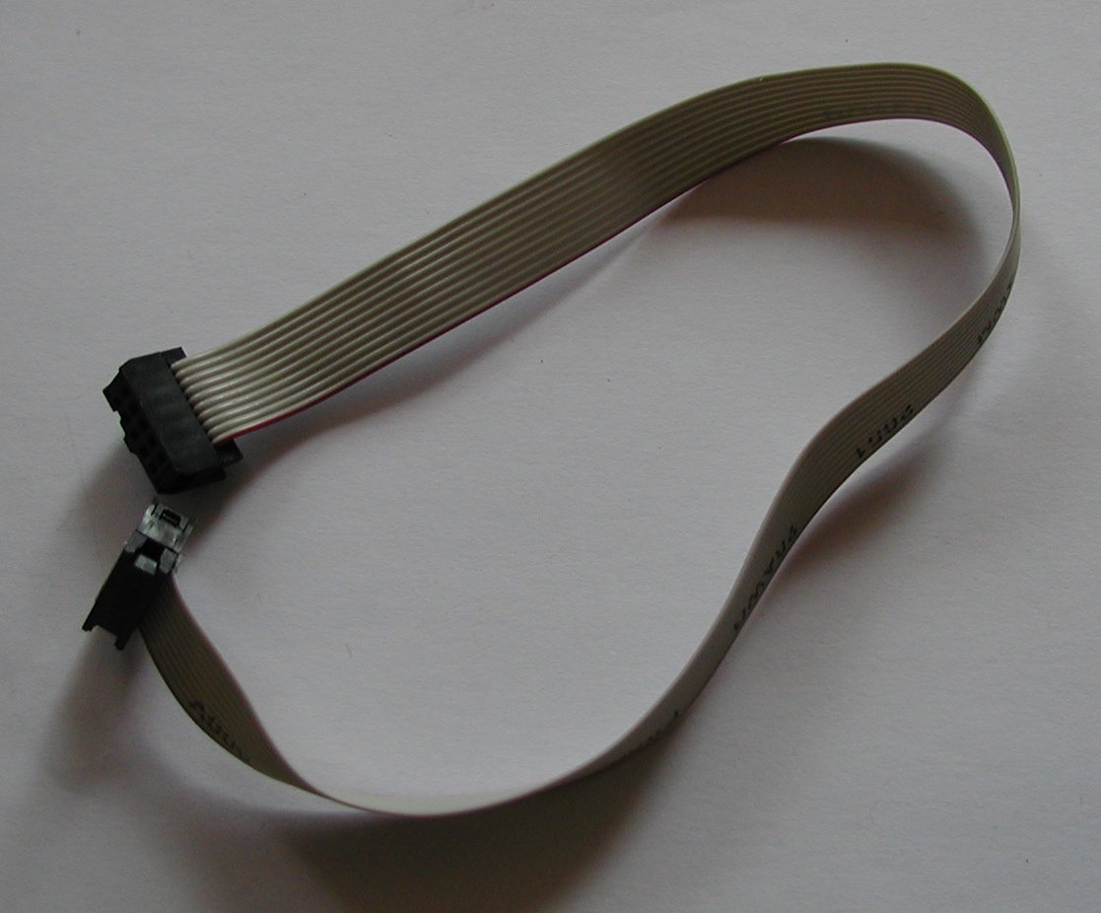
Pinout:

Name | Position | Description
Gnd | 1 | Ground
Gnd | 2 | Ground
PWR_DIRECT | 3 | Triac control (continuous power)
PWR_SSTART | 4 | Triac control (soft-start)
FAN_SENSE | 5 | Tachometer output
FAN_PWM | 6 | Fan PWM speed control
DOUT2 | 7 | Power relay control
+5V | 8 | +5 V for Arduino Shield
Gnd | 9 | Ground
+5V | 10 | +5 V for Arduino Shield

Arduino USB cable
Length | 300 or 500 mm
Type | USB Micro to 5-pin receptacle cable
TME | N/A
Farnell | N/A
AliExpress | e.g. High Quality 50CM micro usb 5pin male to 1x 5Pin Female 0.1" USB header PCB motherboard cable
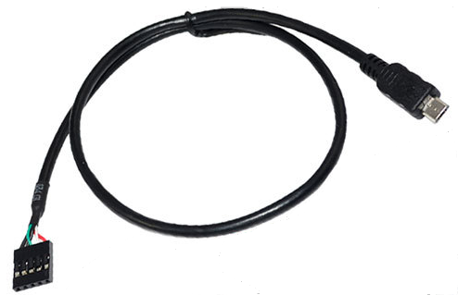
Pinout:

Name | Position | Color | Description
VCC | 1 | Red | +5 Vdc
D- | 2 | White | Data -
D+ | 3 | Green | Data +
GND | 4 | Black | Ground
Shield | 5 | Black | Shield

BOM
Type | Part (Farnell) | Part (TME) | Total
Receptacle | 865667 | NSR-08 | 2
Receptacle | 143127 | MX-6471-031 | 1
Receptacle | 143126 | MX-6471-021 | 1
Receptacle Mini-Fit Jr. | 9963480 | MX-5557-03R2 | 2
Receptacle Mini-Fit Jr. | 9963502 | MX-5557-05R2 | 1
Pin | 1022219 | NDR-T | 15
Pin | 2063734 | MX-0850-0114 | 5
Pin | 9732675 | MX-5556-T3L | 11
Female quick disconnect | 3625424 | BM01148 | 6
Ferrule | 841195 | H0.75/14D/GY | 6
Ferrule, twin entry | 1121751 | H0.75/15D2/GY | 5
Ring terminal | 7356528 | BM 91103 | 1
Cat5e cable | 1602385 | HELUKAT100-FTP-FP | 0.25 m
0.75 cm² cable (Brown) | 2528103 | LGY0.75/25-BR | 0.47 m
0.75 cm² cable (Blue) | 2528092 | LGY0.75/25-BL | 0.47 m
0.75 cm² cable (Red) | 2528175 | LGY0.75/25-RD | 0.73 m
0.75 cm² cable (Black) | 2528082 | LGY0.75/25-BK | 0.73 m
0.75 cm² cable (Yellow-Green) | 2528140 | LGY0.75/25-YL/GR | 1.77 m
0.35 cm² cable | 2425402 | LGY0.35/25-BR | 0.29 m
12 Vdc cooling fan | – | MB60251V1-G99 | 1
NTC | 1187031 | NTCLE100E3103JB0 | 1
IDC ribbon cable | – | FC10300-0 | 0.3 m
USB Micro cable | Search Aliexpress |  | 0.5 m

